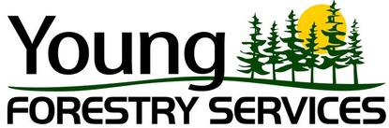

EMPLOYMENT OPPORTUNITY
Chainsaw Operator

Young forestry Services is a local company providing right-of-way maintenance clearing to high profile utility companies. Work consists of brushing and clearing trees and brush from pipeline right of ways throughout Ontario.

We require brush saw, chainsaw, labourers and equipment operators. Employees must be experienced, mature, responsible and reliable. Prepared to travel to throughout Ontario to work on ROW maintenance clearing, as well as other public and private properties.

QUALIFICATIONS:

- Experienced with Brush saws, Chainsaws
- Experienced with heavy machinery
- Must be willing to work long hours and weekends
- Must be able to work outside in all-weather types
- Must be willing to travel (Ontario)-accommodations and food allowance provided
- Must be physically fit

First consideration given to those with heavy equipment certification or experience and minimum Class G License.

Work is on a contract basis. Please forward your resume to:

reception@youngforestryservices.com or fax it to 705-478-7058

3 Maang Road, Nipissing First Nation, North Bay, Ontario P1B 8G5
Phone: 705-472-7400, Fax: 705-478-7058
Email: reception@youngforestryservices.com
www.youngforestryservices.com

